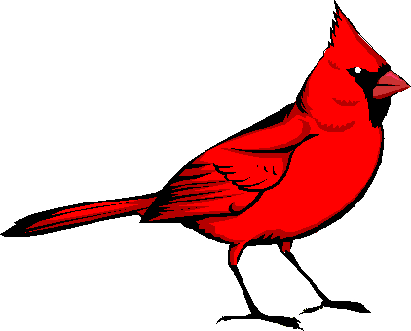Conococheague Audubon

P.O. Box 20 🞄 Fayetteville, PA 17222

www.ConococheagueAudubon.org 🞄 conaudubon@outlook.com

**Contests: Best Bird Photo of the Year**

*Older Age Group* 16-18 years of age // or *Younger Age Group* 5-15 years of age

1. The Best Bird Photo of the Year Contests will begin December 1, 2024 and end with the October 2025 regular Conococheague Audubon Society (CAS) 7 PM meeting on October 13, 2025.
2. Contest details:
3. Older Age Group contest open to students 16 years of age through 18 years of age as of December 1, 2024.

Younger Age Group contest open to students 5 through 15 years of age as of December 1, 2024.

1. Each contestant may submit up to three photos. All photos must be taken during the contest period.
2. Contestant must submit the following when turning in the photo(s): **name, age, contact information (telephone number, email address, mailing address), parent /guardian name(s)**.
3. For each photograph submitted, the contestant must record the **common name of the bird species photographed, date when the photo was taken, and location where the photo was taken.**  Multiple photos of one species may be submitted. A total of three photos, **size 5” X 7”**, may be submitted for consideration. For location, record the city, state, and a brief description (e.g. my home near Chambersburg, PA; Caledonia State Park near Fayetteville, PA).
4. Contestant must record the name/brand of camera used to take each photo. Examples include Canon PowerShot SX530 HS, Nikon D5600, iPhone 16, LG V35 THINQTM, Samsung Galaxy S24, etc.
5. Contestant must have one parent/guardian affirm that contestant is truthful in his/her photograph information and that he/she is indeed the photographer of each submitted photo.
6. Contestant should place photo(s) into an envelope with the information listed in items C-F included.
7. Contestant will submit the photo(s) and completed permission slip at Conococheague Audubon’s regular October 2025 meeting (Monday, October 13, 2025 at 7 PM, St. Luke Evangelical Lutheran Church, 2695 Luther Ridge, Chambersburg, PA (off Scotland Exit#20 of I-81). CAS personnel will decide the winners when all photos have been submitted and verified. Winners will be notified before the November 10, 2025 meeting. Winners will be announced at the November 10, 2025 regular CAS meeting.
8. First prize winner will receive **$50**; second prize will receive **$35**; third prize will receive **$25**.
9. Parent/guardian must grant permission in writing to publish the winner’s name, age, photo, and selected winning photo in our CAS Naturally newsletter, local media, and announcements made at 2024-2025 Conococheague Audubon meetings and special events.

**Contestants do not need to be members of the National Audubon Society or Conocoheague Society.**

Note: Questions may be posed to the CAS Vice President, Terri Kochert, via phone 717-263-3692 or email [conaudubon@outlook.com](mailto:conaudubon@outlook.com). If needed, FAQs will be posted at [www.ConococheagueAudubon.org](http://www.ConococheagueAudubon.org)